Please fill in the street address for each of these items. Answers will be posted on the website on July 5. A larger photo for each item is shown in the Scavenger Hunt blogpost.

# / Thumbnail Item Description Street Address

1. 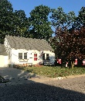 windsocks in the tree and/or ________________________
field of pinwheels
2. 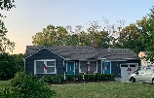 vertical flags on every window ________________________

3. 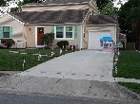 flag-lined driveway ________________________

4. 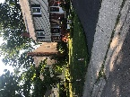 a little bit of everything! ________________________

5. 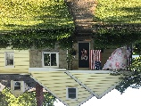 groovy tie dye ________________________

6. 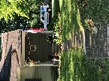 America sign ________________________

7. 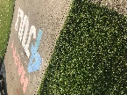 driveway chalk art ________________________

8. 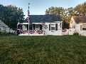 bunting and flags ________________________

9. 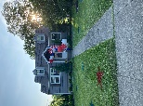 spray-painted yard / balloon arch ________________________

10. 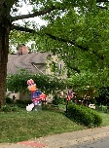 Uncle Sam blow-up ________________________

